**CHAPTER V**

**RESULTS AND DISCUSSIONS**

The data presented in this chapter were results of the survey conducted by the proponents. The collected data are presented in graphical form. The result displayed comprise of experience in using Intelligent Personal Assistant.

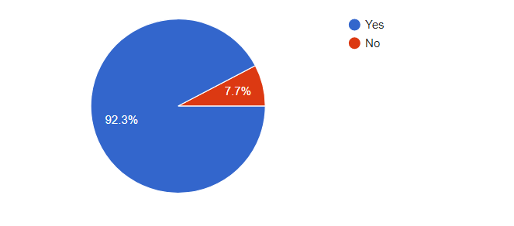

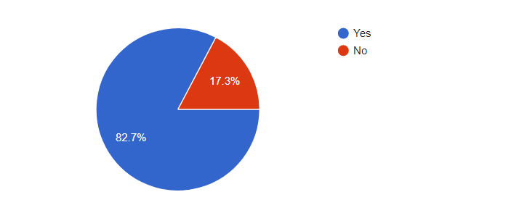**Figure # Awareness about the Intelligent Personal Assistant or IPA**

**Figure# Have tried using an IPA**

Based from the respondents’ answers on the questions “ Are you aware about the Intelligent Personal Assistant or IPA?” and “Have you tried using an Intelligent Personal Assistant?” Most of them familiar with Intelligent Personal Assistant and most of them have experienced using it.

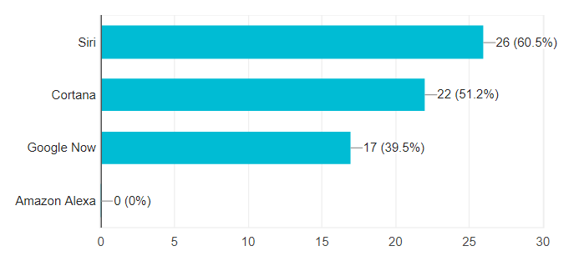

**Figure# Number of IPA users per kind**

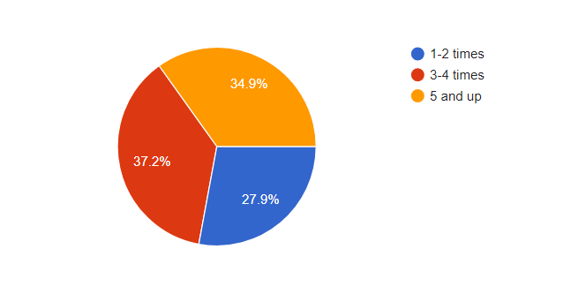From the question “What Intelligent Personal Assistant did you use?” Most of them answered siri because majority of the respondents are fan of apple devices.

**Figure# Number of times they used IPA**

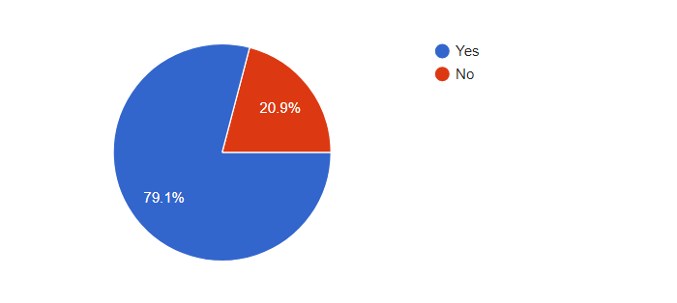Majority of the respondents have enough experience in using intelligent personal assistant. Majority of them have used Intelligent Personal Assistant thrice.

**Figure# Percentage of respondents that find it helpful**

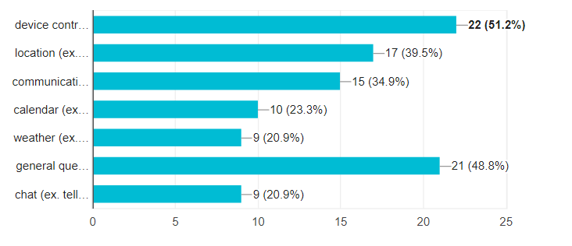Most of the respondents find intelligent personal assistant helpful and reliable in terms of direction time, device control and searching purposes.

**Figure# Request that usually ask to IPA**

From the question “What kind of request do you usually ask?” all of the respondents answered device control. Most of the respondents use Intelligent Personal Assistant for turning up or muting volume, start a specific app like grab or uber.

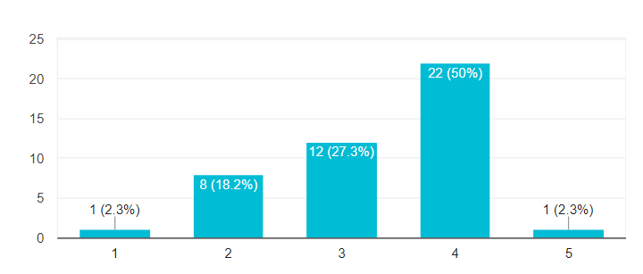 **Figure# Accuracy of IPA 5 as the highest and 1 as lowest**

From the question “How will you rate accuracy response?” majority of the respondents find Intelligent Personal accurate in their own definition. Most of them are satisfied in the main features if Intelligent Personal Assistant

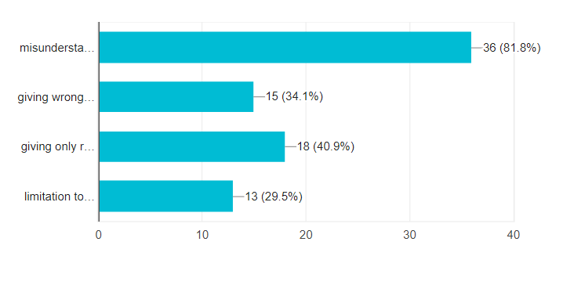

**Figure# Problems encountered while using IPA**

From the question “What kind of problems did you encounter when you use the Intelligent Personal Assistant” majority of the respondents have problem with the IPA always misunderstanding their intent. If you ask the IPA to open a specific app, it will open the app you didn’t ask instead

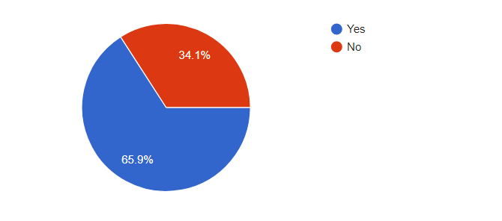

**Figure# Customizable by own preferences**

From the question “If you were to have your own IPA, would you prefer it to be customizable base on your own preferences?” majority of the respondents want to be their IPA to be flexible and customizable as possible.